Top 10 High Activity Areas of Rodents

House Mouse
- Secluded corners
- Beneath cabinets
- Furniture voids - couches, chairs, dressers
- Bases of kitchen appliances - refrigerator, stove
- Ceiling and wall voids near corners and heat sources
- Top of basement and crawl space foundation walls
- Cluttered, neglected office drawers in desks
- Storage boxes in closets
- Cluttered garages
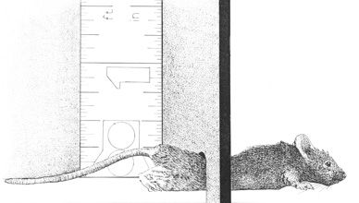
- Bases of water heaters

[back to top]

Norway Rats
- Basements
- Beneath wood piles
- Near or beneath outside dog pens
- Garage walls near heaters and stored food
- Beneath low-lying decks
- Beneath slab walkways
- Within brick foundation wall voids
- Beneath low-lying and cavernous shrubbery
- Within 100 ft of dumpsters and garbage cans
- Beneath slabs supporting food bins
[back to top]

Roof Rats
- Attics
- False ceiling areas
- Within fruit trees
- Wall and floor voids in upper floors
- Within dead fronds of palm trees
- Among overgrown vegetation along fence rows and utility poles
- Within brick foundation wall voids
- Beneath low-lying and cavernous shrubbery
- Among utility lines connected to exterior of home
- Beneath slab walkways

