Inspectors Service Group LLC
Administrative office and mailing address
21720 Hardy Oak Blvd. #94 San Antonio, Texas 78258
(210) 274-0204 (210) 978-5220
admin@isgtx.com www.inspectorsservicegroup.com
Branch Offices –
401 Congress Ave. #1540 Austin, Texas 78701
6060 N. Central Expressway #500 Dallas, Texas 75206
5100 Westheimer Rd. #200 Houston, Texas 77056

Photos of WDI

Subterranean termites
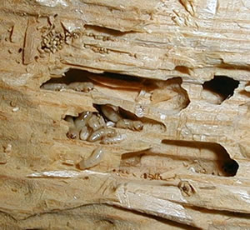
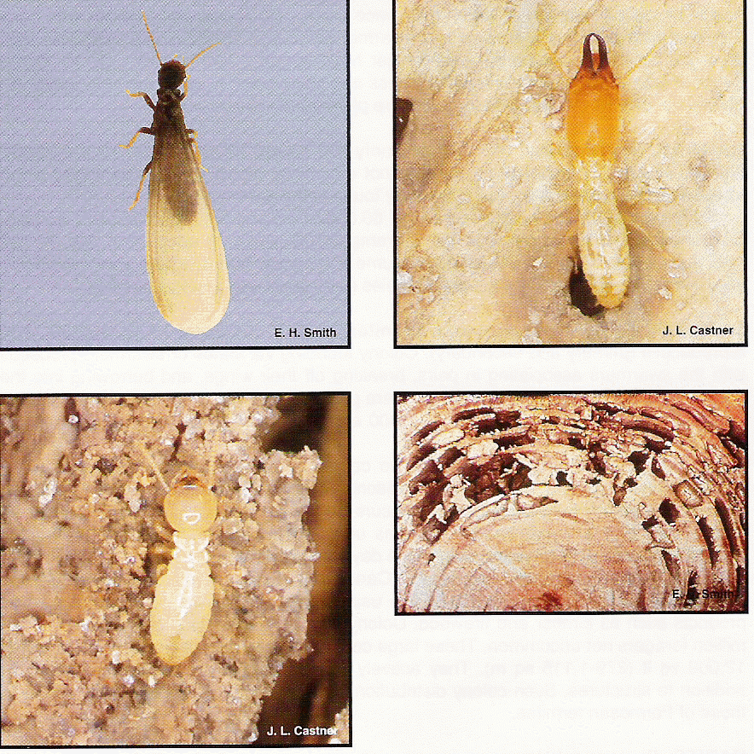

Drywood termites Formosan termites

Carpenter ant Carpenter ant damage Carpenter ant frass

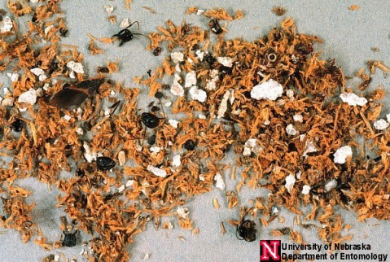

Carpenter Bee Powderpost beetle damage
